LAB 2

2.1 write a program to create a class in which find out the area of trapezoid.
Source Code
class trapazoid_area():
def trapazoid_area(self):
a = input("Enter 1st Base: ")
b = input("Enter 2nd Base: ")
h = input("Enter Height: ")
a = float(a)
b = float(b)
h = float(h)
area = ((a+b)/2)*h
print("The Area of the trapazoid is: ", area)

call = trapazoid_area()
call.trapazoid_area()

Output
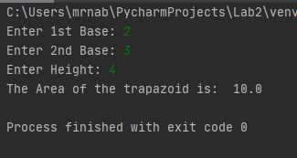

2.2 write a program to create a class in which you create the details of patient records and display it.
Source Code
class Record():
def patient(self):
print("=====Hospital New Patient Form=====")
num1 = input("Enter your Name: ")
num7 = input("Enter your Father's name: ")
num2 = input("Enter your Birthday: ")
num3 = input("Enter your Age: ")
num4 = input("Enter your Gender: ")
num5 = input("Enter your Blood group: ")
num6 = input("Enter your Address: ")

print("Patient's Name : ", num1)
print("Patient's Father's name: ", num7)
print("Patient's Birthday : ", num2)
print("Patient's Age : ", num3)
print("Patient's Gender : ", num4)
print("Patient's Blood group : ", num5)
print("Patient's Address : ", num6)

call = Record()
call.patient()
Output
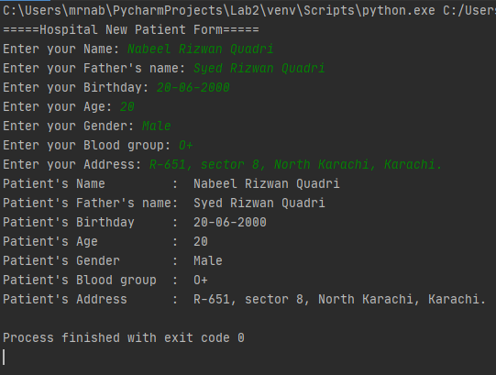

2.3 write a program to create a class in which you convert rupees into dollars.
Source Code
class currency_conversion():
def convert(self):
a = input("Enter amount in rupees: ")
a = float(a)
convert = a/160.45
print("The amount in Dollars is: ", convert)

call = currency_conversion()
call.convert()

Output
